**PS Injuries**

As I did with MR injuries, I generated a series of plots to assess the prevalence and distribution of PS injuries over time and across mines. In this investigation, I specifically probed the prevalence and distribution of two measures of PS injuries:

1. The number of PS injuries per hour worked in each mine, and
2. The share of total injuries that are PS injuries, per hour worked in each mine.

The first variable probes the frequency of PS injuries that occur in each mine, and the second probes the frequency of the ratio of PS injuries that occur in each mine. Both variables account for exposure to injuries.

**Over Time**

**Overall**

For each year, I calculated the average and median number of PS injuries per hour worked across all active mines in that year. These plots are presented below.

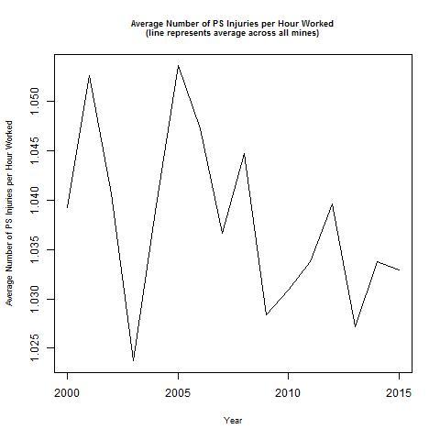 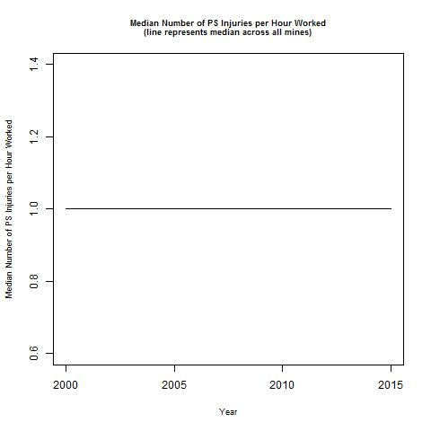

The plot of the average number of PS injuries per hour worked shows a general decrease over time, though there are considerable fluctuations from year to year. In contrast, the plot of the median number of PS injuries per hour worked is consistently at 1.

For each year, I similarly calculated the average and median share of total injuries that are PS injuries, per hour worked across all active mines in that year. These plots are presented below.

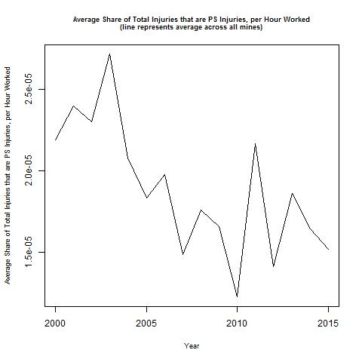 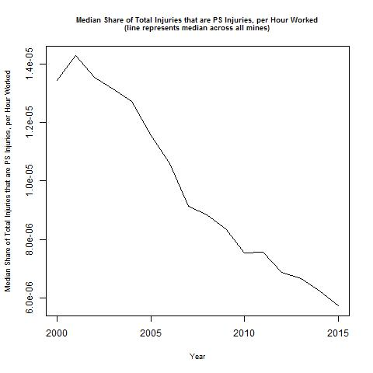

These plots both suggest a decline in the share of total injuries that are PS injuries over time, though they disagree about the rate of the decline. Moreover, the plot of the average share of total injuries that are PS injuries per hour worked exhibits more dramatic year-to-year variation in the outcome. Given that the plot of the median share of total injuries that are PS injuries per hour worked does not have these spikes, one may understand that the spikes are caused by extreme values in a few mines.

**By Hours**

I grouped mines by the number of hours worked in two ways:

1. Dynamically: Every year, a mine was classified as large if it was at or above the 80th percentile for number of hours worked (among active mines in that quarter), as medium if it was at or above the 50th percentile for number of hours worked (but below the 80th percentile for number of hours worked) (among active mines in that quarter), and as small if it was below the 50th percentile for number of hours worked (among active mines in that quarter). This method is described as “dynamic” because the mines comprising the large, medium, and small hours groups can change from year to year; relatedly, a mine can be considered small, medium, and/or large over its lifetime in our dataset.
2. Statically: A mine is considered as large if it is in the 80th percentile for number of hours worked (among active mines in that quarter) for every quarter in which it is active, and is classified as small otherwise. This method is described as “static” because the mines comprising the large and small hours groups does not change, and relatedly, a mine can only be considered small *or* large.

For each year, I calculated the average and median number of PS injuries per hour worked across all active mines in that year, separate for each of the groups described above. The plots displaying the groups of mines defined dynamically are presented below (red = small, green = medium, blue = large).

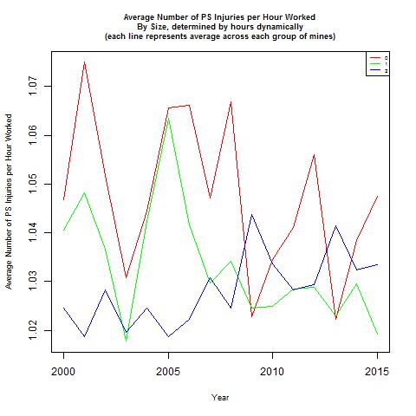 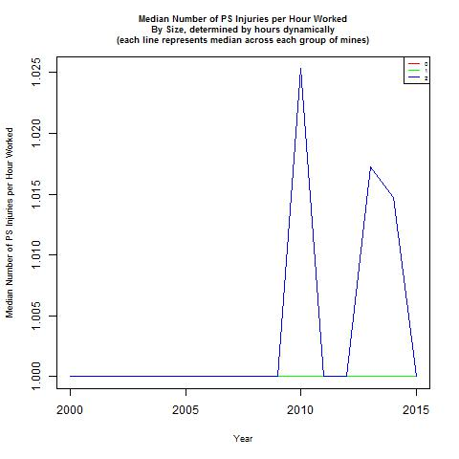

The plot of the average number of PS injuries per hour worked shows that the groups’ injuries fluctuate dramatically and with different trends; however, it appears there is more dramatic fluctuation – for all groups – in the 2000-2010 time period. In contrast, the plot of the median number of PS injuries per hour worked suggests that most groups have a consistent value of 1, except for large mines, which spike a few times.

The plots displaying the groups of mines defined statically are presented below (small = red, large = blue).

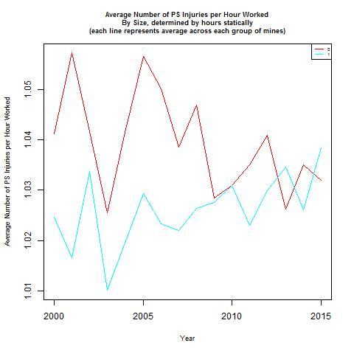 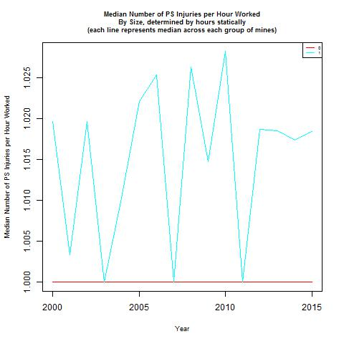

The plot of the average number of PS injuries per hour worked shows that over most years, small mines have a higher number of PS injuries per hour worked compared to large mines. In contrast, the plot of the median number of PS injuries per hour worked shows that over most years, large mines have a higher number of PS injuries per hour worked compared to small mines.

For each year, I also calculated the average and median share of total injuries that were PS injuries per hour worked across all active mines in that year, separate for each of the groups described above. The plots displaying the groups of mines defined dynamically are presented below (red = small, green = medium, blue = large).

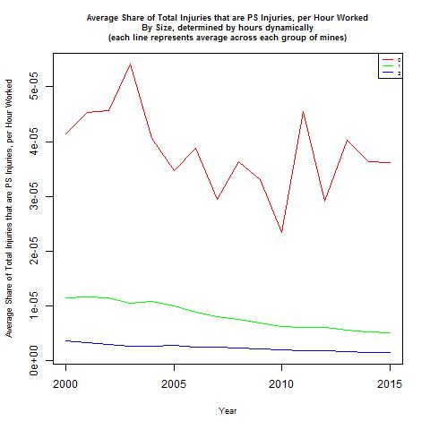 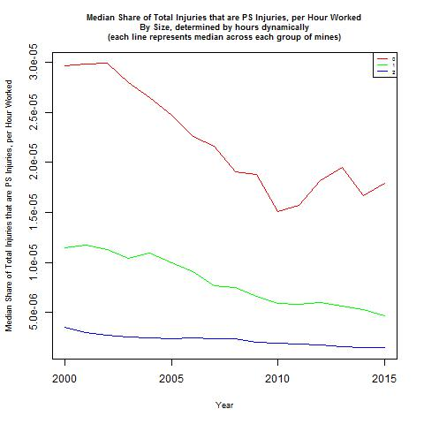

Both plots show that for the entire study period, small mines have a higher share of total injuries that are PS injuries per hour worked than do medium mines, which have a higher share of total injuries that are PS injuries per hour worked than do big mines. According to these plots, large and medium mines experience a fairly consistent share of total injuries that are PS injuries per hour worked, whereas small mines exhibit more dramatic fluctuations (this is especially true for the plot of the average share of total injuries that are PS injuries per hour worked).

The plots displaying the groups of mines defined statically are presented below (red = small, blue = large).

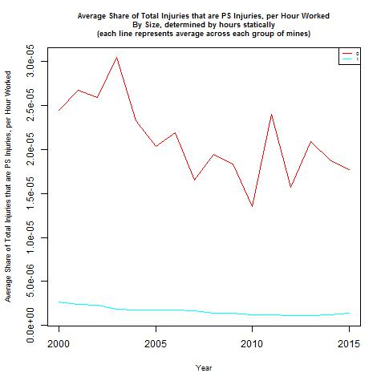 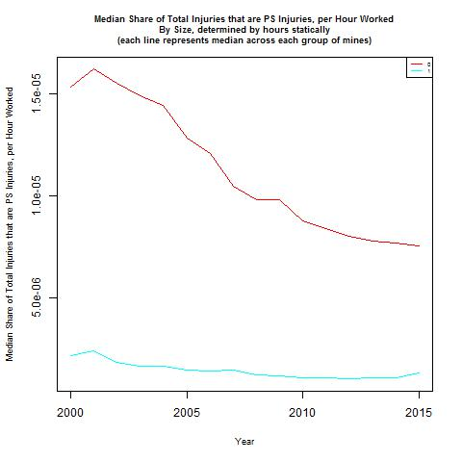

Both plots show that for the entire study period, small mines have a higher share of total injuries that are PS injuries per hour worked than do large mines. According to these plots, large mines experience a fairly consistent share of total injuries that are PS injuries per hour worked, whereas small mines exhibit more dramatic fluctuations (this is especially true for the plot of the average share of total injuries that are PS injuries per hour worked).

**By Employment**

I grouped mines by the number of employees in two ways (mirroring the grouping based on hours described above):

1. Dynamically: Every year, a mine was classified as large if it was at or above the 80th percentile for number of employees (among active mines in that quarter), as medium if it was at or above the 50th percentile for number of employees (but below the 80th percentile for number of hours worked) (among active mines in that quarter), and as small if it was below the 50th percentile for number of employees (among active mines in that quarter). This method is described as “dynamic” because the mines comprising the large, medium, and small hours groups can change from year to year; relatedly, a mine can be considered small, medium, and/or large over its lifetime in our dataset.
2. Statically: A mine is considered as large if it is in the 80th percentile for number of employees (among active mines in that quarter) for every quarter in which it is active, and is classified as small otherwise. This method is described as “static” because the mines comprising the large and small hours groups does not change, and relatedly, a mine can only be considered small *or* large.

For each year, I calculated the average and median number of PS injuries per employees across all active mines in that year, separate for each of the groups described above. The plots displaying the groups of mines defined dynamically are presented below (red = small, green = medium, blue = large).

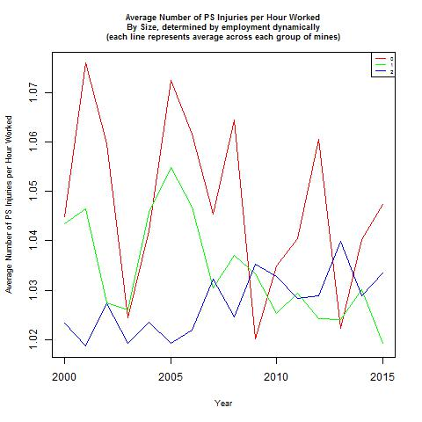 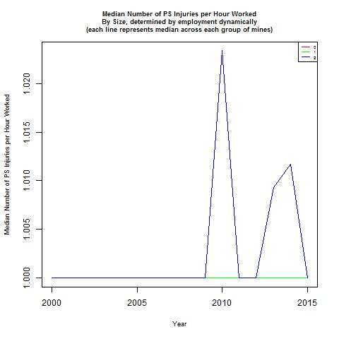

These plots tell a similar story as the corresponding ones for groups based on hours.

The plots displaying the groups of mines defined statically are presented below (small = red, large = blue).

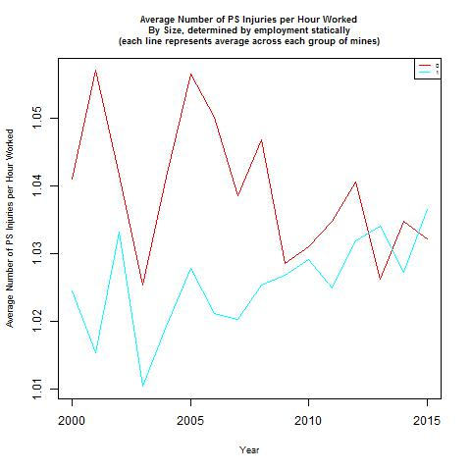 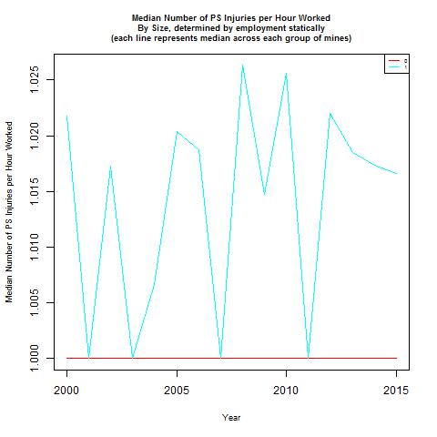

These plots tell a similar story as the corresponding ones for groups based on hours.

For each year, I also calculated the average and median share of total injuries that were PS injuries per hour worked across all active mines in that year, separate for each of the groups described above. The plots displaying the groups of mines defined dynamically are presented below (red = small, green = medium, blue = large).

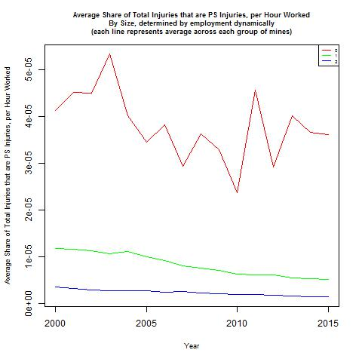 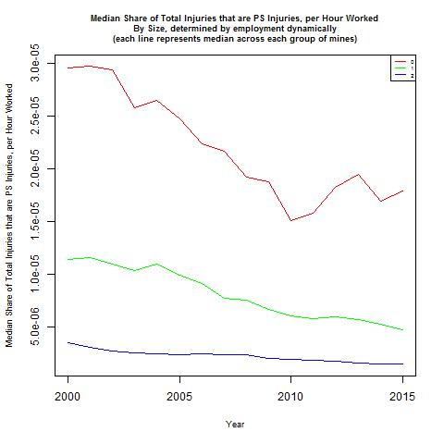

These plots tell a similar story as the corresponding ones for groups based on hours.

The plots displaying the groups of mines defined statically are presented below (red = small, blue = large).

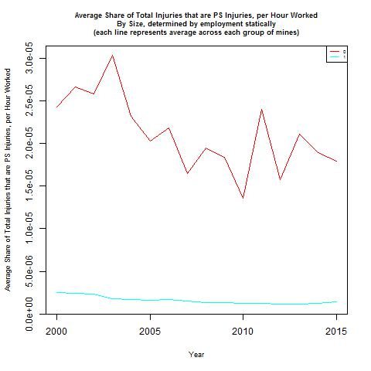 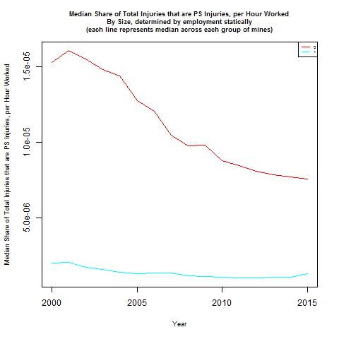

These plots tell a similar story as the corresponding ones for groups based on hours.

**By Production**

I grouped mines by their coal production in two ways (mirroring the grouping based on hours and number of employees described above):

1. Dynamically: Every year, a mine was classified as large if it was at or above the 80th percentile for coal production (among active mines in that quarter), as medium if it was at or above the 50th percentile for coal production (but below the 80th percentile for number of hours worked) (among active mines in that quarter), and as small if it was below the 50th percentile for coal production (among active mines in that quarter). This method is described as “dynamic” because the mines comprising the large, medium, and small hours groups can change from year to year; relatedly, a mine can be considered small, medium, and/or large over its lifetime in our dataset.
2. Statically: A mine is considered as large if it is in the 80th percentile for coal production (among active mines in that quarter) for every quarter in which it is active, and is classified as small otherwise. This method is described as “static” because the mines comprising the large and small hours groups does not change, and relatedly, a mine can only be considered small *or* large.

For each year, I calculated the average and median number of PS injuries per hour worked across all active mines in that year, separate for each of the groups described above. The plots displaying the groups of mines defined dynamically are presented below (red = small, green = medium, blue = large).

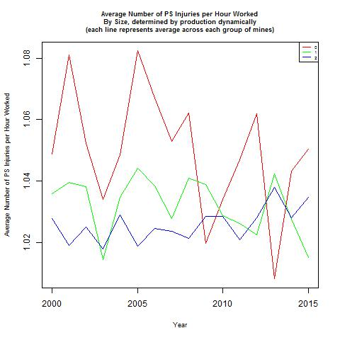 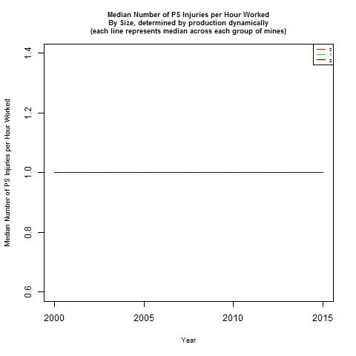

These plots tell a similar story as the corresponding ones for groups based on hours and employment, except the plot of the median number of PS injuries per hour worked does not show any difference between groups.

The plots displaying the groups of mines defined statically are presented below (small = red, large = blue).

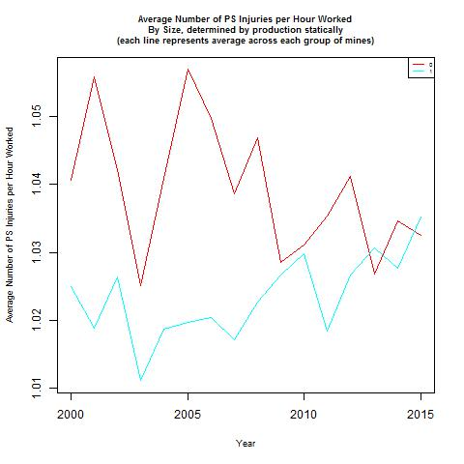 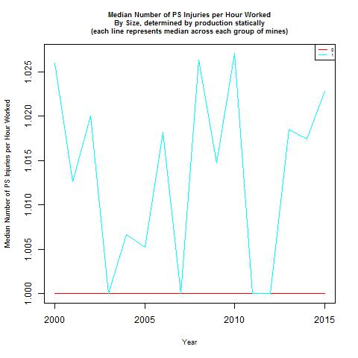

These plots tell a similar story as the corresponding ones for groups based on hours and employment.

For each year, I also calculated the average and median share of total injuries that were PS injuries per hour worked across all active mines in that year, separate for each of the groups described above. The plots displaying the groups of mines defined dynamically are presented below (red = small, green = medium, blue = large).

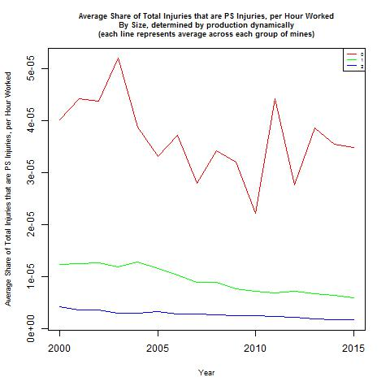 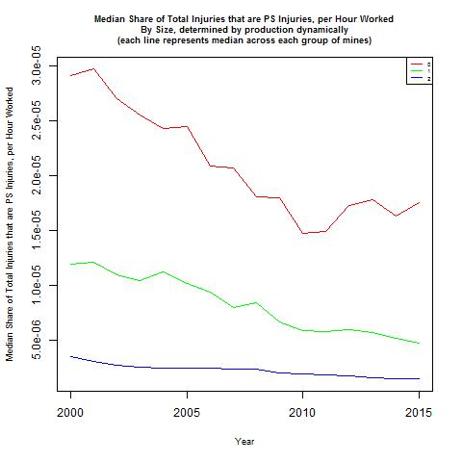

These plots tell a similar story as the corresponding ones for groups based on hours and employment.

The plots displaying the groups of mines defined statically are presented below (red = small, blue = large).

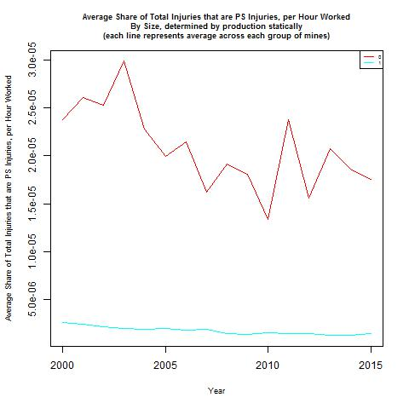 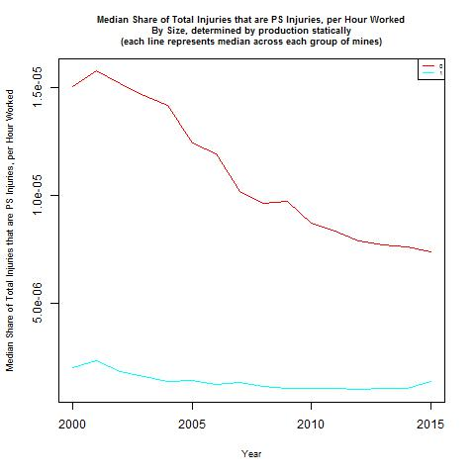

These plots tell a similar story as the corresponding ones for groups based on hours and employment.

**By District**

For each year, I calculated the average and median number of PS injuries per hour worked across all active mines in that year, separate for each district. These plots are presented below.

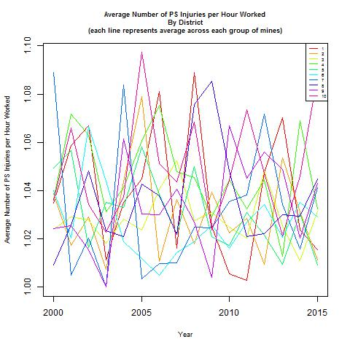 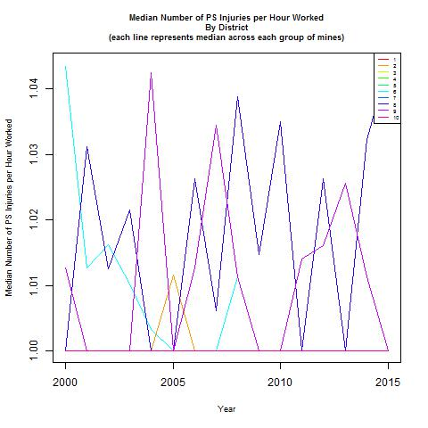

Both plots show that there is considerable variation in the number of PS injuries per hour worked both across districts at each time, and within each district over time. Moreover, the time trends within each district do not follow a clear pattern. However, the plot of the median number of PS injuries per hour worked suggests that two districts contain the most at every time period of, as well as the most variation in, PS injuries per hour worked.

For each year, I also calculated the average and median share of total injuries that were PS injuries per hour worked across all active mines in that year, separate for each district. These plots are presented below.

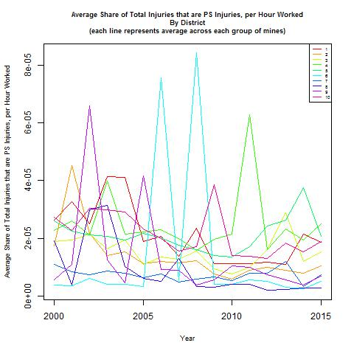 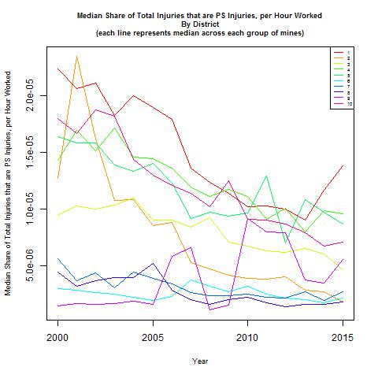

As with the plots concerning the number of PS injuries per hour worked, these plots show that there is considerable variation in the share of total injuries that are PS injuries per hour worked both across districts at each time, and within each district over time. And again, these time trends within districts do not follow a clear pattern. However, the plot of the median share of total injuries that are PS injuries per hour worked suggests that there may be two groups of districts – one containing a higher, and the other a lower, share of total injuries that are PS injuries over time.

**By Appalachia**

For each year, I calculated the average and median number of PS injuries per hour worked across all active mines in that year, separate for mines in Appalachia (blue) and mines not in Appalachia (red). These plots are presented below.

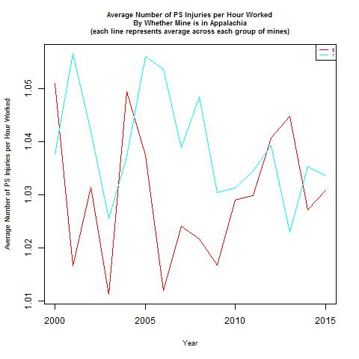 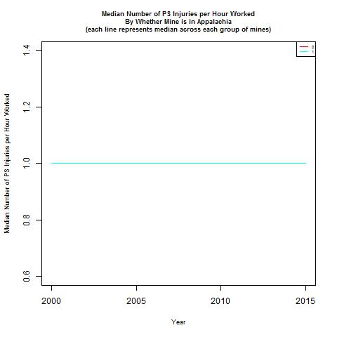

The plot of the average number of PS injuries per hour worked shows that over many years, mines in Appalachia have more PS injuries per hour worked than mines not in Appalachia. However, there are many years that are exceptions. In contrast, the plot of the median number of PS injuries per hour worked is consistently at 1 for both groups of mines.

For each year, I also calculated the average and median share of total injuries that were PS injuries per hour worked across all active mines in that year, separate for mines in Appalachia (blue) and mines not in Appalachia (red). These plots are presented below.

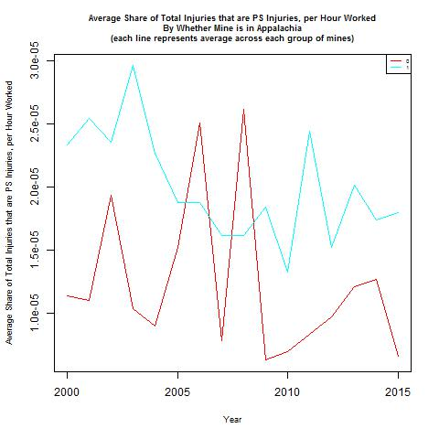 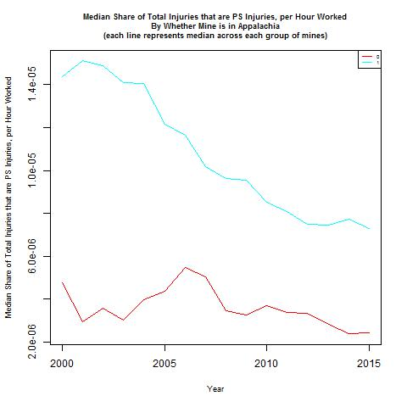

These plots both show that it is mines that are in Appalachia that have a higher share of total injuries that are PS injuries per hour worked compared to mines not in Appalachia. Notably, the plot of the median share of total injuries that are PS injuries per hour worked shows somewhat depressed spikes compared to the plot of the average share of total injuries that are PS injuries per hour worked, suggesting that these spikes may be driven by a few mines with extreme values.

**By Safety Committee**

For each year, I calculated the average and median number of PS injuries per hour worked across all active mines in that year, separate for mines that had no safety committee (red) and mines that had a safety committee (blue). These plots are presented below.

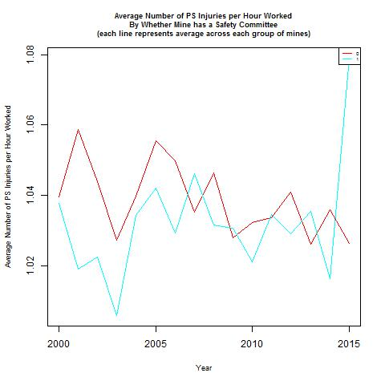 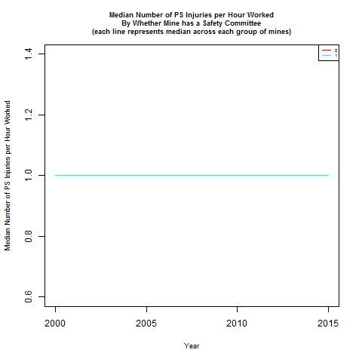

The plot of the average number of PS injuries per hour worked shows that over many years, mines without a safety committee have more PS injuries per hour worked than mines with a safety committee. However, there are some years that are exceptions. In contrast, the plot of the median number of PS injuries per hour worked is consistently at 1 for both groups of mines.

For each year, I also calculated the average and median share of total injuries that were PS injuries per hour worked across all active mines in that year, separate for mines that had no safety committee (red) and mines that had a safety committee (blue). These plots are presented below.

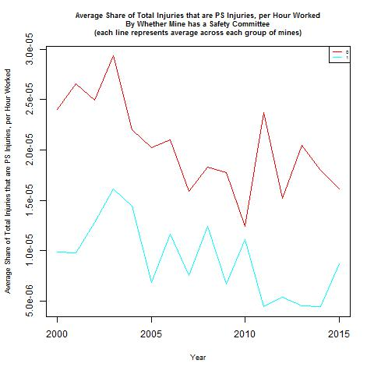 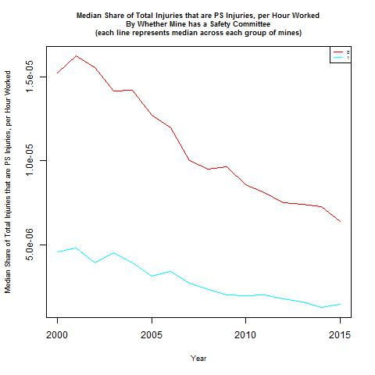

These plots both show that it is mines did not have a safety committee that have a higher share of total injuries that are PS injuries per hour worked compared to mines that had a safety committee. Both plots also suggest that both groups of mines are experiencing a decline in the share of total injuries that are PS injuries per hour worked. Notably, the plot of the median share of total injuries that are PS injuries per hour worked shows somewhat depressed spikes compared to the plot of the average share of total injuries that are PS injuries per hour worked, suggesting that these spikes may be driven by a few mines with extreme values.

**Across Mines**

I calculated the average and the median number of PS injuries per hour worked in each mine (i.e., average and median over time). The histograms for these measures are presented below.

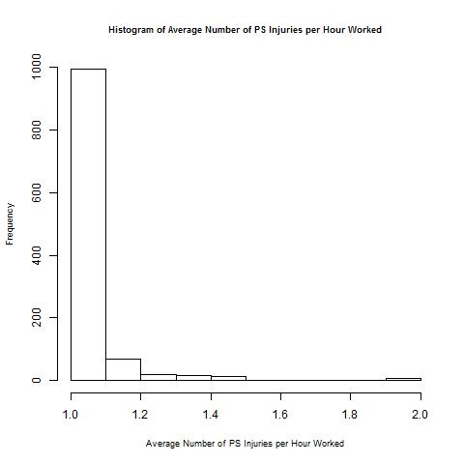 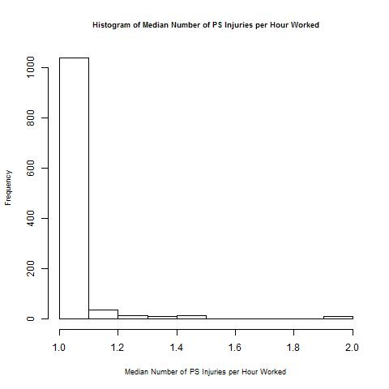

These histograms both show that mines have a distribution of average and median number of PS injuries per hour worked skewed towards 0 – this is even more extreme than it was for MR injuries.

I also calculated the average and the median share of total injuries that are PS injuries per hour worked in each mine (i.e., average and median over time). The histograms for these measures are presented below.

As with the histograms of average and median number of PS injuries per hour worked, these histograms both show that mines have a distribution of average and the median share of total injuries that are PS injuries per hour worked skewed towards 0.

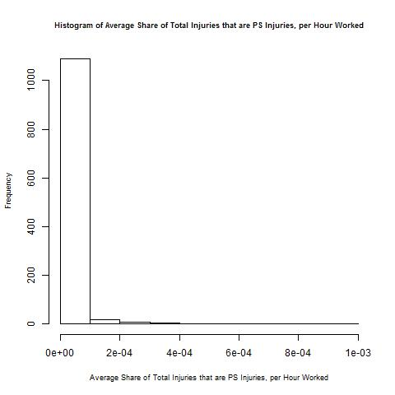 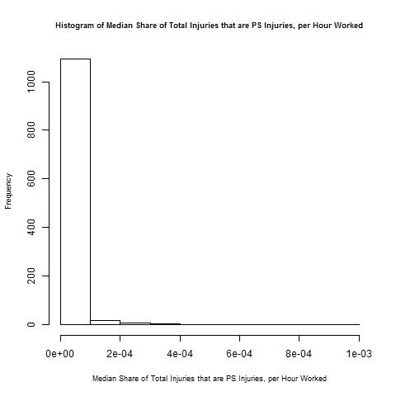

For each mine, I calculated the correlation between the number of PS injuries per hour worked and year, and between the share of total injuries that are PS injuries per hour worked and year. The histograms for these measures are presented below.

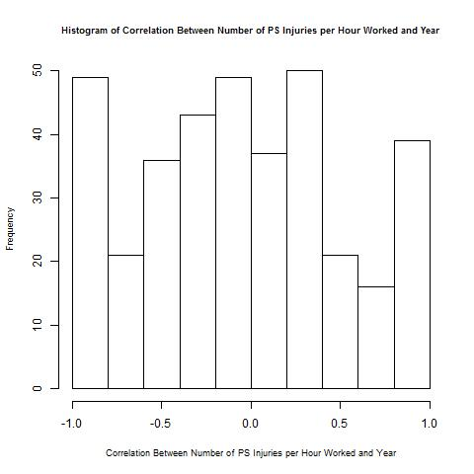 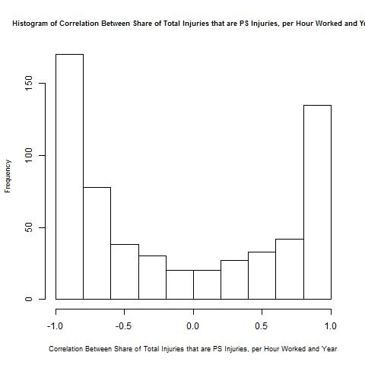

These plots show that both for both correlations, there are a high share of mines with extremely positive or negative correlations, with the distributed in between. Notably, for the correlation between the number of PS injuries per hour worked and year, there are a high share of mines with a value of 0. In contrast, for the correlation between the share of total injuries that are PS injuries per hour worked and year, there are a small share of mines with a value of 0.